Te Tira Ahu Pae
RISK ANALYSIS AND MANAGEMENT SYSTEM (BASIC RAMS FORM)
Club Name |  | Event Name
Location
Description of Event
Target Audience
Crowd numbers
Event start date |  |  | End date
Event start time |  |  | Event end time
Name of Responsible person: |  |  | Contact Number During event
Alternative contact person |  |  | Contact Number During event
Communication procedure on the day
Phone/text/face to face
Emergency Procedures: Serious accident, bomb threat, fire, earthquake, hazardous substance, act of violence, protest action.
For a medical or other emergency dial 111
Consider emergencies that may go wrong and ensure you have a plan in place. Brief event runners on what alternative plans maybe.
Ensure club members have the responsible person’s contact number
Know facility evacuation plan and assembly areas
Treatment:
A First Aid kit/Room/Station is available where:
Defibrillator Available where: Call Massey Security
On-Site Health and Safety Person:

Accident, Injury Reporting and Treatment
- All accidents involving injury on the event site during the set up and breakdown periods are to be reported to the Responsible Person on site, and later to the Clubs’ and Events Coordinator.
- The nature of the accident will be investigated, and any necessary preventative action identified and taken
- All accidents on the Massey University site or off site will be recorded in the site Accident Register held by the TE TIRA AHU PAE and reported on to Massey University. Notifiable events to WorkSafe NZ on 0800 030 040
- During public access at the event, accident reporting and treatment will be undertaken by the on-site Event Health and Safety Person.
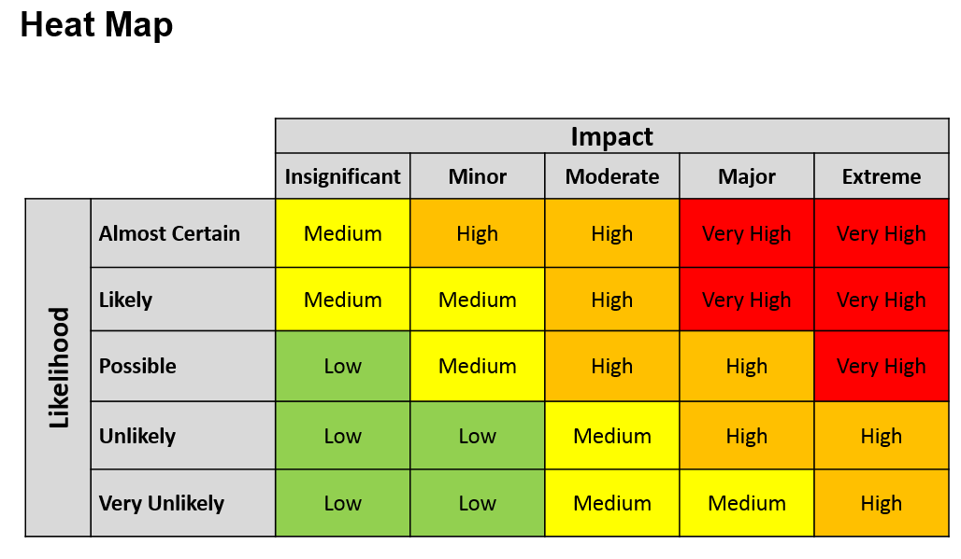

General Site Risk Assessment

Complete the below. Examples have been added to show you how to use the matrix above.
HAZARD  (What is the Risk) | PERSONS AT RISK  (Who is at Risk) | Initial  Risk  (Where the hazard falls on the heatmap) | CONTROL MEASURES  (What you going to do to stop, or minimise the impact or likelihood of the hazard) | Residual Risk  (Where it now falls on the heatmap) | ACTION BY  (Who is responsible for the control measures)
Manual Handling | Site Crew | MED | Only authorised and properly instructed individuals to take part in manual handling, where risk is present.  Appropriate lifting equipment used where possible by authorised personnel. | LOW
Waste Management | All | MED | Adequate numbers of bins provided for event based on participant numbers. All decorations and left over food will be disposed of in the appropriate | LOW
Wires & Plugs | All | HIGH | All installations correctly fitted, tested, and used.  All cables adequately covered, as necessary. | LOW
Pack-in | Site Crew | MED | Safety briefing with all crew about site rules.  First Aid kit on site at all times. | LOW
Uncooked Food | All | MED | All uncooked food will be cooked at high temperature (70c for 2min) and checked it is heated well through before serving.  Gloves to be worn while handling food. | LOW
 |  | VERY HIGH |  | HIGH

